Chapter 9, Solution 85.

Let 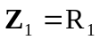, 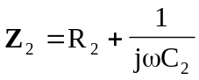, 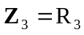, and 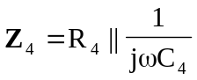.
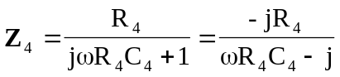

Since 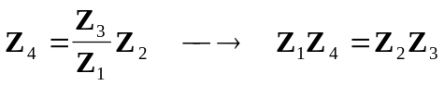,
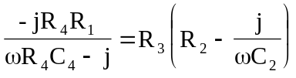
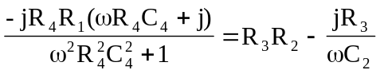

Equating the real and imaginary components,
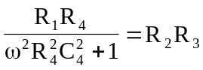 (1)
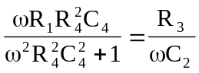 (2)

Dividing (1) by (2),
